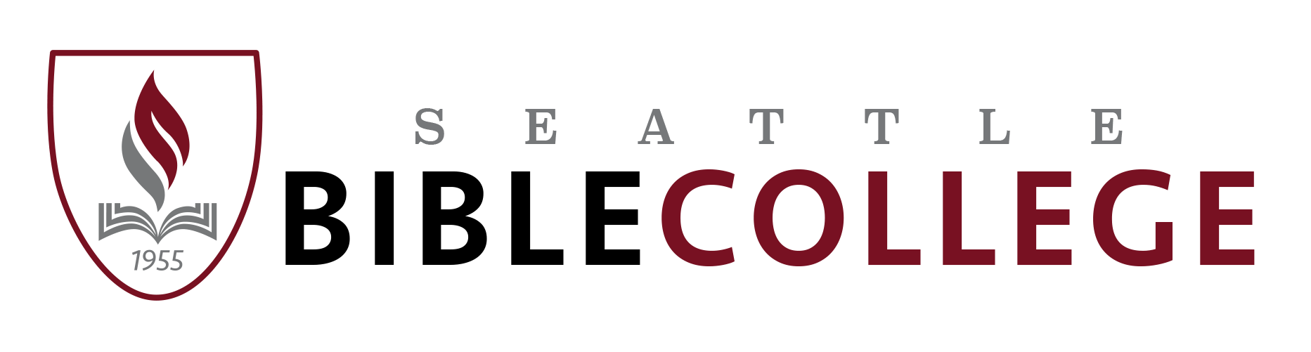
leadership track at Sonrise Christian Center

11625 Airport Rd. Everett, WA 98204

Winter Quarter, 2018 Schedule (Jan. 2 – Mar.16; Finals: Monday Mar.19)

TUESDAY - 9 mornings – Jan. 2, 9, 16, 23, 30; Feb. 6, 13, 20, 27.
PT/GS 313 HOMILETICS I - NT Preaching Pastor John Hammer 3 credits
This course studies methods for sermon preparation, focusing on developing and effectively delivering various forms and types of sermon from the New Testament.
Chapel – prayer/small groups - 8:30 a.m. – 9:30 a.m.
1st period - 9:45a.m. – 11:00 a.m. 2nd period - 11:15 a.m. – 12:30 p.m.

WEDNESDAY - 9 mornings – Jan. 3, 10, 17, 24, 31; Feb. 7, 14, 21, 28.
GO 143/243 PRINCIPLES OF EVANGELISM Dr. Dan Hammer 4 credits
This course will deal with effective ways in which to reach people for Christ. The student is led in gaining an awareness of the value of each person, identifying methods of leading a person to Christ and recognizing “discipleship” as the biblical goal of evangelism.
1st period (Prayer) – 8:30 – 9:00a.m. 2nd period – 9:10 a.m. – 10:10 a.m.
3rd period – 10:25 a.m. – 11:25 a.m. 4th period 11:35 a.m. – 12:30 p.m.

THURSDAY, 9 mornings Jan. 4, 11, 18, 25; Feb. 1, 8, 15, 22; Mar. 1.
BI 324 GENERAL EPISTLES Pastor Anthony Simmons 3 credits
Examines the epistles of Peter, John and Jude to discover the occasion, purpose, structure, contents, message and the practical application.
Chapel – prayer/ministry - 8:30 – 9:30 a.m.
1st period - 9:45 – 11:00 a.m. 2nd period - 11:15 a.m. – 12:30 p.m.

FRIDAY, 8 mornings – Jan. 5, 12, 19; Feb. 2, 9, 16, 23; Mar. 2 & Mar. 5 – 8 Local Outreach Week OR Mar 5 – 16 Mission Trip
GO 405/ RML 613 MISSIONS THEN & NOW Pastor Chris Ward 3 credits
This course of study examines the importance of Christian missions and its’ spread from the days of the early apostles through todays modern mission’s movement.

Chapel – prayer/worship/ministry - 8:30 – 10:00 a.m.
1st period -10:10 – 11:15 a.m. 2nd period - 11:25 a.m. – 12:30 p.m.

NOTE: JAN. 2 - 4 WILL BE SPIRITUAL GROWTH WEEK.
CHAPEL WILL BE FROM 8:30AM - 11:00AM
REGULAR CLASSES BEGINNING FROM
11:15 – 12:30PM
THIS WEEK ONLY.

2

MODULAR COURSES

JANUARY 25 – 27 WORSHIP MODULAR

WS/GS 201 SONGWRITING FOR WORSHIP Pastor Barry Eggehorn 3 credits

RML 632 SONGWRITING FOR WORSHIP (MASTER’S LEVEL) Pastor Barry Eggehorn 4 credits

This course will provide the student with a hands on journey through the process of writing a corporate and personal worship song while using an array of powerful musical and lyrical tools.

MARCH 5 – MARCH 16 ALL SCHOOL MISSION TRIP

GO 105 GLOBAL OUTREACH Pastor John Hammer 3 credits

This course applies the truths of Christ’s Great Commission into practical ministry. Students will be challenged with cross-cultural realities and missional principles, locally or overseas.
-------------------------------------------------------------------

PT/LS 400 REPRESENT CONFERENCE - Feb 16 & 17 Pastor John Hammer 1 credit

-------------------------------------------------------------------
On-line courses also available subject to approval by SBC administration.
BI//LS 313/RBL 611 NEHEMIAH & LEADERSHIP Pastor Dan Hammer 4 credits
This online course engages the student in the Biblical text of the Book of Nehemiah, explores the leadership themes and principles contained therein, and discovers areas of practical application for the obedient servant of God.
GS/LS 207 SPIRITUAL WALK OF THE CHRISTIAN LEADER Pastor Chris Ward 4 credits
Before leaders can encourage others to grow spiritually, they must learn how to walk in the ways of God. This course will help the student understand this principle and provide a better understanding of their daily walk with God.
BI 526 GREAT WOMEN IN SCRIPTURE Dr. Kathleen M. Troll 4 credits
Examines the lives of some of the great women in the Bible. These character studies provide principles to help motivate and to encourage students to pursue their destiny in God.
-------------------------------------------------------------------

Seattle Bible College 11625 Airport Road Everett, WA 98204 425.212.3530 877.722.9673
info@seattlebiblecollege.edu www.seattlebiblecollege.edu

Seattle Bible College admits students of any race, color, and ethnic origin to all the rights, privileges, programs, and activities generally accorded or made available to students at the College. It does not discriminate on the basis of race, color, national and ethnic origin in administration of its educational policies, admissions policies, scholarship programs, and other school-administered programs.

11-16-17

